Visualizing Action: A Recipe for Boston Innovation Success
By Debra M. Amidon, Founder and CEO ENTOVATION International Ltd.
and Oliver Schwabe, Principal, Eurofocus International Consultants Ltd.

In an era of Big Data, we are challenged to identify signals of progress. In this kaleidoscopic economy where complexity and change are the norm, classical financial indicators are no longer sufficient. Intangible or intellectual value parameters - where knowledge, innovation and collaboration are integral - must be considered. Here we demonstrate a unique tool for social and organizational networking analysis to provide insight with a picture for strategic planning and economic development.

The Innovation Frontier:

In 1994, W. Edwards Deming highlighted management is all about being able to predict what will happen and then making those decisions to bring an organization the greatest benefit. In the fuzzy world of intangible value, select predictors (aside from the classical financial metrics) are difficult to determine. Traditional accounting mechanisms do not provide much light on intangibles.

Further, since knowledge is growing at a geometric rate, we may be approaching the singularity of which Ray Kurzweil writes; and we should not expect that acceleration to slow soon. The pervasive Internet and ERP solutions have enabled a shift from vertical to distributed organizations and the rise of ‘the enterprise’.

More than a decade ago, a monograph including the ‘Economics of Intangible Value’, was commissioned by the Canadian Society of Management Accountants; and TrendMonitor International documented the trends according to valuing, counting and trading. Furthermore in a research report, ‘Creating the Knowledge-Based Company’, measurement was determined to be the area in this new knowledge field showing the largest gap between management expectations and achievement. Measurement of intangible value (perhaps an oxymoron) is the least understood and – at the same time - the most critical activity for success.

In an effort to make sense out of all this new reality, ‘innovation eco-systems’ have become the new modus operandi. How can we reliably predict how to mold organizations for sustainable value in our digitized, networked, knowledge-focused, innovation-driven and complex era?

Clearly, the ability to innovate, and thus adapt to an uncertain future, is the most valuable asset of an enterprise. The challenge lies in understanding what relevant variables can and should be measured. There is some guidance.

Calibrating Performance:

In a trilogy of books on Knowledge Economics, with 27 authors of from 17 countries, a modern economic foundation emerged with three Laws of Knowledge Dynamics:

- The First Law: knowledge multiplies when shared. Knowledge – best referenced and measured in the form of Intellectual Capital (IC) – is the prime asset of 21st Century management. [e.g., The DENSITY of a network is the primary performance metric from a network perspective.]

- The Second Law: value is created when knowledge moves from its point of origin to the point of need or opportunity. The real benefit of knowledge lies in action; innovation is the process where knowledge is put into motion or used. [e.g., The (geodesic-) DISTANCE among participants of a network is the primary performance metric from a network perspective.]

- The Third Law: mutual leverage provides the optimal utilization of resources - both tangible and intangible. Collaboration - the value of leveraging knowledge of one another - creates greater wealth and sustainability with profound network effects. [e.g., The in-degree CENTRALITY of network participants is the primary performance metric from a network perspective.]

These Laws play a role in how companies approach their strategic thinking even when not stated explicitly. They are even more integral when considering innovation as business strategy.

In last half of the last century with the quality movement, managers discovered the customer as central to marketing strategy. In their ground-breaking book, Treacy and Wiersema outlined the new climate of ‘hyper-competition’ and the resultant need for companies to be expert in one of three arenas: operational excellence, product/service leadership or customer intimacy.

Today, we manage an environment of ‘hyper-collaboration’, in which human and technical interactions need to be diagnosed, monitored, and even incentivized. It is not only customers from whom we need to learn; but the knowledge of all stakeholders (e.g., suppliers, distributors, external research and media sources as well as competitors) needs to be harnessed. The innovation eco-system, in its entirety, becomes the ‘enterprise’ and the unit of performance measurement. We need a new planning platform - beyond the TBL reporting originally developed by Novo Nordisk (see below).

Figure 1: Knowledge Era Trends

Together with Bryan Elliott Davis, founder of the Kaieteur Institute of Knowledge Management (Canada), we examined hundreds of examples of what we call Knowledge Innovation Zones [KIZ] and a number of Intellectual Capital (IC) indicators under development (e.g., the World Economic Forum, the UN, The World Bank, Milken Institute, Robert Huggins Associations, Booz Allen Hamilton, Regional Indexes, City Annual Reports, EUROSTAT, WIPO, The Economist, to mention a few), we developed the Triple Knowledge Lens [TKL] – the triangulation of the Knowledge-based ECONOMY (Markets, Business, and Commerce), Knowledge-based SOCIETY (Networks, Communities and Culture), and Knowledge-based INFRASTRUCTURE (Organization, Environment and Technology).

The Triple Knowledge Lens [TKL] was further refined as Intellectual Capital – Human Capital and Structural – in the form of a new Innovation Value Proposition (see Figure below) with 15 value capital drivers – complete with variables that influence the drivers in a fully functioning system.

For our research study, these were the performance metrics determined to be most relevant to positioning and could be useful as social media diagnostics. Successful leadership in the Knowledge Economy requires a dynamic balance of all 3 axes – not one at the expense of another.

Figure 2: The Triple Knowledge Lens

What was labeled Intellectual Capital in 1987 can now be categorized with a taxonomy defining a variety of intangible variables: This categorization (below) is what shaped the methodology later described in the Boston Innovation Case, a Knowledge Innovation Zone or KIZ.

Value Driver | Label | Description
1. Knowledge Capital | “Gravity” | The power, depth, and breadth of the knowledge assets in your personal portfolio including specialized know-how, experience, and knowledge mastery. [e.g., number of web pages indexed by search engines]
2. Leadership Capital | “Fidelity” | Recognition as having outstanding management qualities, skills, and capabilities for direction forward.[e.g., the relative ratio of centrality in-degree to centrality out-degree]
3. Innovation Capital | “Brightness” | Proven and consistent capabilities regarding the incubation, development, production and of marketing of innovative designs, processes, and systems. [e.g., eigenvector centrality]
4. Entrepreneurship Capital | “Agility” | Recognition for exhibiting entrepreneurial instinct, passion, zeal, drive, and success. [e.g., geodesic distance]
5. Reputation Capital | “Awareness” | Having a positive image and standing in your field as perceived by others. [e.g., Page-Rank in overall ecosystem]
6. Diversity Capital | “Bandwidth” | Proactively maintain, cultivate, and respect variety in your relationships, networks, and community connections. [e.g., variance of organizational types with reciprocated connections]
7. Brand Capital | “Authority” | The degree your identity has visibility, presence, and positive mindshare in the marketplace. [e.g., relative number of authoritative sites linking to a website]
8. Network Capital | “Influence” | The degree of depth, density of far-reaching connections and influence within those networks. [e.g., relative (sub-) network density and centrality]
9. Cultural Capital | “Coherence” | Respect and trust your unique constellation of values and the ethos reflected in your mindset, way of thinking, spirit, learning desire, imagination and creativity.[e.g., structural integrity of the network]
10. Social & Community Capital | “Spread” | Degree of active involvement as contributor, participant, and representative of all that’s good within those social ecologies. [e.g., density and geodesic distance of the network]
11. Strategic Capital | “Integrity” | Formulated business plans in place, business designs, and business models. [e.g., relative number of top level external supply-chain links]
12. Organizational Capital | “Structure” | Enterprise structures and capabilities in place that provide you with a collaborative advantage across functional, industry and geographic boundaries [e.g., web-farming looking for comments made on the company by employees, customers, suppliers]
13. Intellectual Property Capital | “Protection” | Extent to which you have explicit control of valuable proprietary assets. [e.g., relative number of patents, copyrights etc. registered in the company name]
14. Technological Capital | “ICT Enablement” | Degree of sophistication and prowess of the information technology infrastructure. [e.g., web-farming looking for technology related news on the company]
15. Environmental Capital | “Greenness” | The degree to which socially responsible, sustainable, and green values have been internalized into your current practice. [e.g., relative number of connections to relevant umbrella organizations]
Risk | Complexity | The reliability with which the future dynamics of the ecosystem can be predicted. [e.g., relative strength of reciprocal connections]
Figure 3: 15 value Driver Approximations

Case Example: The Boston Innovation Landscape

In many competitive innovation ranking reports, the United States is slipping; and the slide to mediocrity is imperceptible. In the Atlantic Century II, it is reported, the United States ranks 43rd out of 44 nations. In the same report, however, if Massachusetts were a country, it ranks #1 in the world – ahead of Finland, Sweden, Singapore, Denmark, Japan, South Korea and Belgium. What are the differentiators; and can we easily visualize?

The same ITIF organization produces a New Economy Index comparing all the States in the United States; and Massachusetts has led the ranking for the last five years. Additionally, Boston is the #1 World Innovation City. Boston is the #1 Digital City in America; and Boston Convention Center is the #1 in the country. The State ranked #1 in the Race-to-the-Top education competition; and is a lead recipient of Federal R&D across several industry sectors as well as major marketplace for Venture Capital. Arguably, it represents one of the most prominent zones of innovation in the United States and the world. Might we glean some insights as to why?

Recently, Boston was the destination venue for a week-long innovation tour by 52 CEO’s from four Regions of Northern Italy. As preparation, a Massachusetts Knowledge Innovation Zone [MA-KIZ] ChoiceBoard was compiled as exemplars of the local region innovation leadership. The program, sponsored by CONFINDUSTRIA (the Entrepreneur Association of Italy), was organized as 6 Case Stories with CEOs and 10 modules ranging from MIT; Boston Innovation District; Harvard University; Kendall Square; Babson College/Olin College of Engineering; IBM/Consulates; Legal Sea Foods Quality Control Center; MOITI; Collaboration Gene; and the Best of Boston. It was intended to survey the local innovation branding, activities of start-up companies, the changing roles of executive managers from the perspective of the City of Boston, the Commonwealth of Massachusetts and the New England Region. Care was taken to position all in a global context and future management challenges; and over 65 local experts participated. The learnings from this activity were applied to the subject of this article.

Our visualization analysis was based a diagnosis of 15 of the ChoiceBoard organizations with methodology that is easily transposed into any other context. Organizations evaluated included: AIM, Artaic, Babson College, Boston University, CleanTechOpen, Deloitte, EMC, Entrepreneur’s Network [ENet], Hult International University, iRobot, Mass Challenge, MassTLC, Swissnex, TEDxBeaconStreet, and Xconomy.

How can we use our diagnostics to create visuals that capture the activities creating the dynamic exchange of knowledge that typifies a sustainable innovation zone? We assume that Density, Distance and Centrality – according to the 3 Laws of Knowledge Dynamics – represent ‘goodness’.

Then, we examined underpinnings of the innovation fabric - the organizational network diagnostics of the zone. The focus of this analysis lies in demonstrating how digital ecosystems, as reliable approximations of the ‘real’ world, can be visualized. Thus, they can be used to:
- identify where in the ecosystem an organization wishes to ‘play’,
- define tactical measures for moving toward the desired position,
- propose a way to monitor progress, and
- set the stage for a Knowledge Innovation strategy which would embed the needed new behaviors in their organization.

We also assume those digital networks, being products of human collaboration (and hence living systems), reflect “brick and mortar” reality and thus provide actionable insights based on the laws of knowledge dynamics: density, distance and centrality.

Methodology

The 15 selected organizations were subjected to a web-crawl diagnostic approach developed through several EU studies and supported by a custom designed web-crawling application provided by Eurofocus International Consultants Ltd.

The method essentially completes a series of continuously refined web-crawls to identify linked websites, refines the generated network view based on a set of focused innovation value drivers [See Figure 3] and then aggregates these into an overall ecosystem view based on filtering techniques developed over decades.

The result below illustrates the “Massachusetts-15” innovation ecosystem in which the aggregated organizational networks are displayed. Connections and edges are not displayed for the sake of simplification. Further layout calibration was completed based on the approach developed at the Digital Methods Initiative in the Netherlands.

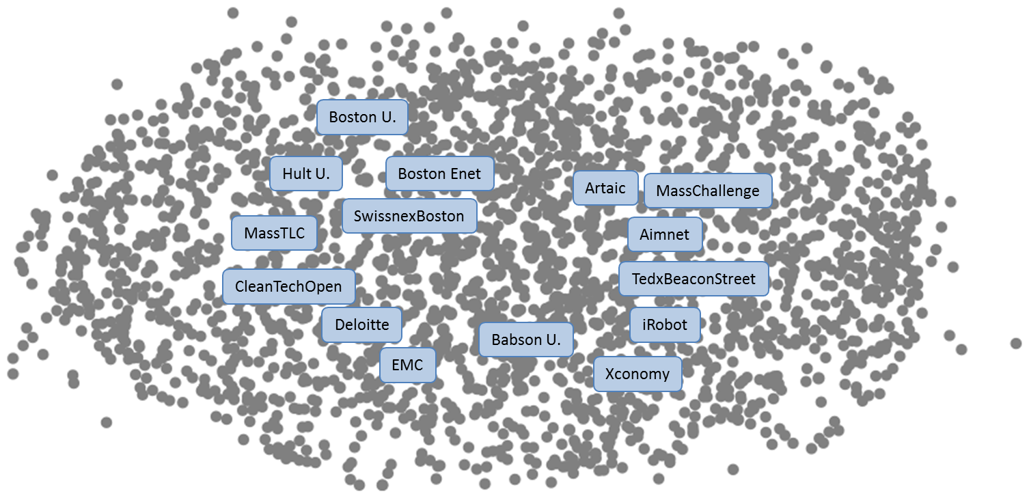

Figure 4: The Massachusetts-15 Innovation Ecosystem

This digital ecosystem consists of 2,482 organizations and the 3,398 reciprocated links between them.

For illustration, the following figure uses ‘AIMnet’ – the network of the Association of Industries of Massachusetts [AIM] – founded in 1915 and comprised of enterprises employing one out of every five workers in the Commonwealth and representing almost every sector of the economy.

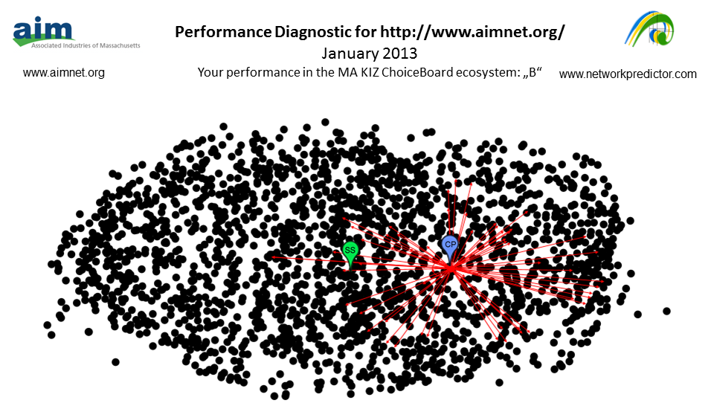

Figure 5: Top-Level View of the AIMnet Ecosystem

The blue “CP” icon identifies the current position of AIMnet within the digital ecosystem. The green icon “SS” identifies the “sweet spot” or center of the digital ecosystem – that position where we believe the potential for value-creation by an organization is highest. Based on the distance of AIMnet to the center of the network, a basic “grade” can be assigned ranging from “A” if located in the middle of the ecosystem to an “F” is located at the periphery of the ecosystem. AIMnet is given a B grade in this analysis.

A further perspective of relevance illustrates the AIMnet-centric view of the network as highlighted in the next figure. It provides an opportunity to see some of the prominent connections as well as contrast a pure web diagnostic view with one more focused on the intangible performance measures of an innovation eco-system designated in the ENTOVATION Navigator.

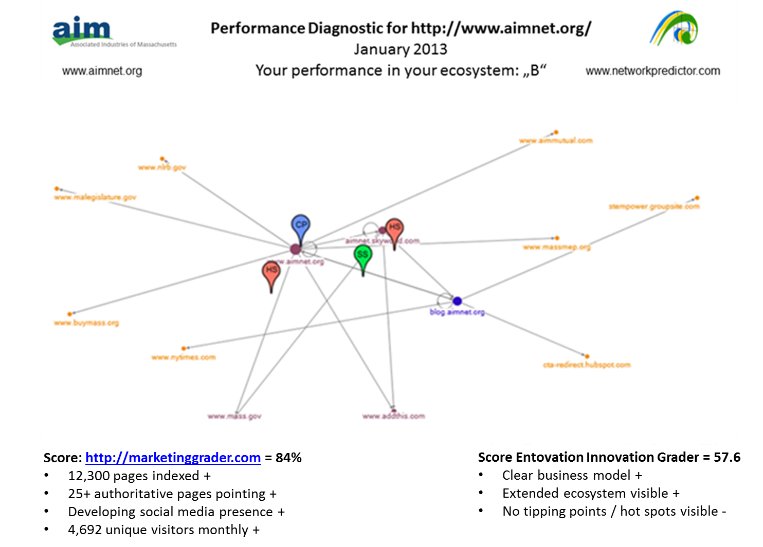

Figure 6: The Digital Ecosystem of AIMnet

The red icon “HS” marks a “hot spot”, therefore a region of notably high level of connectivity. Additionally, a review of the website through the use of HubSpot’s Marketing Grader solution enabled identification of key social media elements of the AIMnet presence.

Finally, a high level assessment based on the value-driver approximations allowed for verification of overall positioning. Take note that digital presence, from a high level, is not sufficiently mature to identify relevant ecosystem pivot points that point to efficient optimizations. The label ‘pivot’ - versus a ‘tipping’ - is consciously chosen as a ‘pivot’ may involve a turn, spin around, revolve or rotate whereas ‘tipping’ (i.e., a tilt, lean, angle. Incline or slant) options are more limited.

Verification involved: (1) applying the value-driver approximations of the organizations and then (2) correlating the relevant scorings with the performance diagnostic grade for the organizations in the overall ecosystem. This correlation validates the effectiveness of the ecosystem mapping method as a reliable approximation of innovation capability and potential for value-creation.

Each of the 15 organizations were evaluated in this manner and then the generated ecosystems aggregated, as pieces of a puzzle, into the overall ecosystem illustration as shared above. The network data gathered for each of the 15 organizations was tabulated (below) based on the Triple Knowledge Lens performance metrics.

Figure 7: TKL Scoring of the Massacshusetts-15

There are 4 rankings provided: one for each of the 3 Laws of Knowledge Dynamics and an Overall Score. The scores are simply an artifact of the process of evaluation. Relative ranking is the significant factor. It should also be noted that all 15 enterprises were selected from the ChoiceBoard because of their innovation prowess.

The below figure illustrates the potential correlation between awareness (Page-Rank) of an organization within its own eco-system and its awareness (Page-Rank) in the overall ecosystem. The finding indicates that the positioning of an organization within the overall ecosystem relates strongly to how to shapes its own ecosystem.

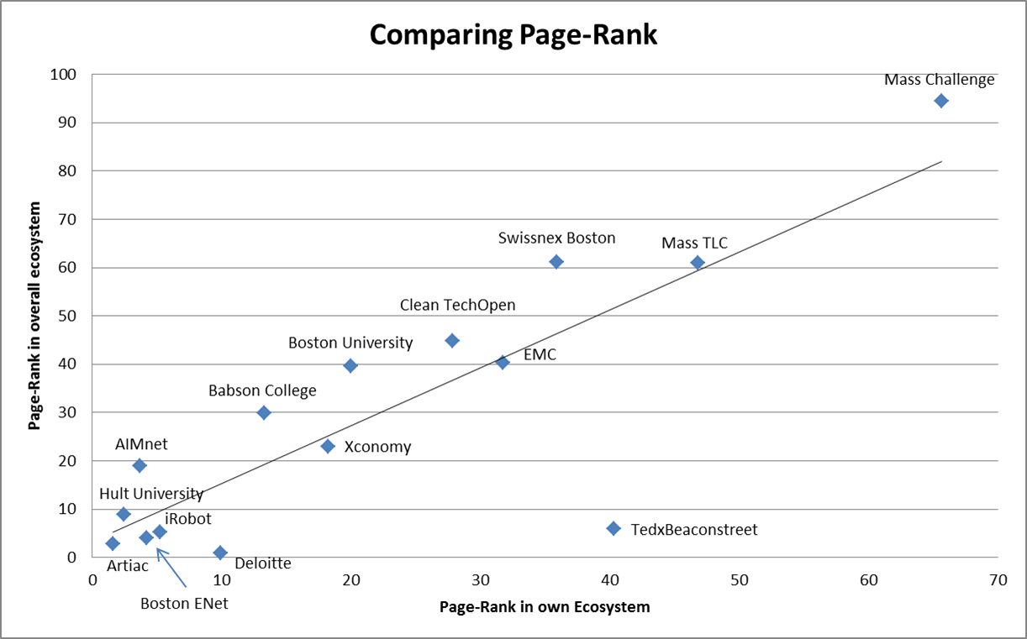

Figure 8: Scatterplot correlation of Page-Rank (Awareness)

In order to identify the key innovation players in a KIZ, it is hence potentially sufficient to determine those organizations with the highest Page-Rank in the regional or industry ecosystem. Once these are known, the ecosystems themselves can be developed leveraging these with the P⁷ methodology, while start-ups / ventures in the zone might need to align themselves as intensively with these key innovation players.

Keep in mind that AIMnet is one of many organizations selected through the Knowledge Tour research as a suitable participant on the MA ChoiceBoard; and hence, by default, belongs to the more influential of the 2,482 organizations identified as participating in the MA-15 focused digital ecosystem. Further research and expansion of the effort to include all participants of the ChoiceBoard will help verify this.

Is AIMnet the “key” player in the MA-15 ChoiceBoard KIZ? It is definitely one of the major influencers of the KIZ Knowledge Innovation dynamics. Each of the organizations has relative strengths and contributions to the overall eco-system and likely has influenced the exceptional ranking of Massachusetts in the nation and around the world.

Initial Findings

The intent of the innovation research was to explore whether the TKL performance of an organization in their ecosystem could be approximated using advanced organizational network mapping techniques and custom-designed web-crawling/grading solutions in a rapid, reliable and practical manner.

- Through the simplification of research-based performance metrics of Knowledge Innovation systems (i.e. TKL and the value-drivers) we found it was possible.

- This result promises the potential to introduce reliable performance monitoring solutions as support for ecosystem development approaches and governance.

- While traditional organizational network analysis focuses primarily on centrality of an organization in the network, our research study demonstrated the TKL perspective leads to a more balanced view of performance diagnosis because it considers multiple perspectives of relevance.

- Focus on the key competence of Knowledge Innovation capabilities of an enterprise offer an entrée to moving the enterprise and its stakeholders into their sustainability sweet spot.

- The study validated a rapid innovation capability assessment method for organizations that can be performed externally and with reasonable effort.

- It also validated a technical solution and method for quickly and easily generating visual maps of an organization’s (digital) ecosystem with sufficient richness to highlight actionable decision-making to improve value-creation. This is especially relevant considering solutions and methods available to-date require significantly greater effort and generate fewer insights.

- The research study furthermore suggests a way to monitor the position of an organization’s ecosystem in the market-space and a way to compare the value-creation of an organization to that of others in the market-space.

The web-crawling solution provides an initial map of the market space relevant to the inquiring organization. The challenge, then, lies in calibrating this map with the detailed TKL value-drivers in order to indicate the relative competitive advantage of the organization. The question that arises is whether it is possible to validate this scoring against relevant third-party measures; so further validation research is to be explored.

With these insights, what are the tools and processes to move an enterprise within the ecosystem? How do we move these organizations (and their stakeholders) toward their desired sweet spot?

Action: Operationalizing Results

We are amidst what MIT professor Michael Stonebraker, a co-founder of seven Big Data companies, refers to as a ‘data tsunami’. In Massachusetts alone, it is reported there are at least 100 Big Data companies, dozens more in stealth mode and thousands of professions who are users of big data technologies. Most are already familiar with the 3 V’s – Volume, Velocity, and Variety – originally outlined by Gartner; and the 4th enhancement - Variability - added by IBM. Now, the literature and conference presentations includes (at least) three new additions: Value (and Valuation), Vision and Visualization.

This resulting 7V Factor provides a challenge for the most adept management team. We need to rethink our approach to managing a future which is economically viable amidst inevitable kaleidoscopic change. We need to use all tools and analytics available, such as those represented here, to visualize action. It is a first step – an entrée into innovation implementation.

Armed with the tactical and strategic insights from the web innovation diagnostics, a prescriptive framework is provided as the P⁷ KIZ Assessment – a social systems design methodology to manage programs from concept through full-scale implementation. Knowledge, as the asset of abundance to be managed, has a magnifying effect as represented in the P⁷ (i.e., P to the 7th power). P⁷ targets the flow of knowledge – amidst the network connections - with a new mindset and systematic assessment process based upon inspiration, insight and interaction. The P⁷ KIZ assessment explores the following perspectives – ingredients for success:

- P¹ Smart Innovators have a sense of purpose
- P² SmartInnovators guide with a set of principles
- P³ Smart Innovators understand the full process of innovation
- P⁴ Smart Innovators gauge financial and non-financial performance
- P⁵ Smart Innovators want governing policies – ethical and transparent
- P⁶ Smart Innovators use ‘bench-learning’ to monitor practices
- P⁷ Smart Innovators know prosperity depends upon stakeholder innovation
Figure 9: The P⁷ KIZ Methodology

Organizations, by nature, are organic and operate within their (digital) ecosystem -whether they know it or not. These ground-breaking intangible performance metrics allow management to capitalize on their positioning from a network eco-system perspective that is not part of current management paradigms. The foundation for building ‘collaborative advantage’ can be laid – a strategy which can be seminal to success.

Conclusion

Today, we need to manage the innovation environment – not leave it to serendipity. Managing is a function of creating the conditions where innovation can occur – where ideas flow efficiently into and within the system and are converted into viable products and services that create highest value.

The current research, by default, provides, a static ‘snap-shot’ of the Massachusetts innovation ecosystem. It is a useful starting point for introducing a repeatable and empirical monitoring capability of ecosystem development and performance. As the number of these digital ecosystems mapped globally grows, comparative diagnostics are possible. The insights generated, while supporting business planning, create a foundation for coherent innovation strategies and relevant performance.

Being able to visualize market-spaces, diagnose current and potential value-creation, defining an action strategy to maximize positioning and determining optimal stakeholder constellations are critical management capabilities in today’s economy. The jury is out whether this network perspective can be considered as a ‘new game in town’ or whether it is actually leading to a change in the ‘rules of the game’.

We are in what seems to be a chaotic environment trying to drink from a data hose.
This digital ecosystem perspective offers a simple – but not simplistic - and straight-forward approach for improvement. This method is suitable for static or dynamic monitoring of value-creation capability in a complex systems environment. Pragmatic actionable interventions can be identified; and all sets the stage for embedding a Knowledge Innovation strategy in daily business planning and operations.

The 21st century has given birth to the knowledge-based economy, society and infrastructure establishing a foundation for innovation-based real-time performance. Changes in several fundamental management parameters have a kaleidoscopic effect on managing a company or a country. The Knowledge Era – in contrast to the Industrial or Information Eras - demands solutions that are symbiotic, collaborative and innovative in which people and communities are nurtured.

The research study has demonstrated that digital ecosystem analysis serves as a powerful foundation for a better understanding of how the laws of knowledge dynamics and associated value-drivers are performing. The ensuing diagnostics lead to straight-forward operational measures defined by current search engine optimization (SEO) approaches which demand daily attention by management.

We now have techniques to make the intangible more visible. Whether it is a new ‘game’ or new ‘rules’: now is the time to create the playground, determine the players, cultivate the interaction and mine the results.

Knowledge Innovation® is a registered trademark of ENTOVATION International Ltd.


A global innovation strategist, Debra M. Amidon, founder and CEO of ENTOVATION International Ltd [Wilmington, MA USA], is considered an architect of the Knowledge Economy demonstrating how theories can be applied for practical results. An international thought leader and author; she has published 8 books in foreign translations, including The Innovation Superhighway – acclaimed as the “Innovation Book of the Decade”. Debra has delivered hundreds of articles and keynote presentations in 38 countries on 6 continents. Her clients include Fortune 50 companies, government agencies and enterprises such as the EU, OECD, IADB, UN, the Asian Productivity Organization, the Arabian Knowledge Economy Association and The World Bank. She has advised governments on innovation strategy, such as France, the UK, Singapore, China, India, Colombia, Australia and Saudi Arabia. With her notable E100 Network, her seminal concepts – intellectual capital, knowledge innovation, and stakeholder innovation collaborative advantage - have become the standard-to-emulate. In 2012, Debra hosted the World Summit on Innovation and Entrepreneurship in Boston. Debra holds degrees from Boston University, Columbia University and the MIT where she was an Alfred P. Sloan Fellow.
Contact details: 2 Reading Avenue, Wilmington, MA USA 01887, T: +01-978-988-7995, E-mail: debra@entovation.com, URL: www.entovation.com, www.inthekzone.com.



As experienced strategist and entrepreneur, Dr. Oliver Schwabe has enjoyed several decades of experience in organizational change management and business intelligence with an emphasis on value creation through technology innovation and network-centric principles. Drawing on his skills in bringing compelling strategy blueprints, sustainable business blueprints and effective technology blueprints to life, Oliver heads up Eurofocus International Consultants Ltd which is responsible for helping global clients move effectively from hierarchical to network centric business structures through system dynamics and network analysis driven transformation efforts. Currently Eurofocus is focused on its Network Predictor research venture which specializes in the development of software solutions and methods for the discovery and diagnosis of digital ecosystems. Building on extensive experience in virtual facilitation, online support, learning, organization design and leadership he helps clients nurture sustainably successful strategies based on the principles of the knowledge economy. Oliver has a doctorate in Business Administration and is a faculty adjunct to Capella University and the Open University Business School. He is affiliated with the ENTOVATION Group Alliance as the Fellow for Knowledge Products and Services.
Contact details: Eurofocus International Consultants Ltd., Wassergasse14, 55234 Wendelsheim, Germany; T: +49 (0) 6734 916776; E-mail: Oliver.schwabe@euro-focus.com; URL: http://www.networkpredictor.com; http://de.linkedin.com/in/oliverschwabe

W. Edwards Deming, The New Economics [Cambridge, MA: The MIT Press 1994, Pg. 101]
Kurzweil, Ray. The Singularity is Near: When Humans Transcend Biology[NY: Penguin Books 2006]
Visit: http://www.entovation.com/assessment/trends.htm
Amidon, Debra M. et al. Collaborative Innovation and the Knowledge Economy, [Toronto, Ontario: Society for Management Accountants. 1998]
Skyrme, David J. and Debra M. Amidon, Creating the Knowledge-Based Business [UK: Business Intelligence 1997]
Sahasrabudhe, Amit et al, Performance Ecosystems: A decision framework to take performance to the next level [Palo Alto, CA: Deloitte Development LLC. 2012]
Amidon Debra M., Piero Formica and Eunika Mercier-Laurent (Eds.), Knowledge Economics: Principles, Practices and Policies [Estonia: Tartu University Press 2006]
Treacy, Michael L. and Fred Wiersema, The Discipline of Market Leaders: Choose your Customers [Reading, MA: Addison-Wesley, 1995]
Amidon, Debra M. and Bryan Elliott Davis, “Triple Knowledge Lens” [Spain: IC Magazine February 2006]
Visit: www.inthekzone.com
Visit: http://www.inthekzone.com/pdf/KIZ%20-%20External%20Indicators%20Inventory%20v1%201b.pdf
Amidon, Debra and Bryan Elliott Davis, A Preview: The State of Knowledge Innovation Zones (KIZ) [IVG April 2006]
Amidon, Debra M. and Dan Dimancescu. Managing Knowledge Assets into the 21st Century [Cambridge, MA: Technology Strategy Group 1987]
Atkinson, Robert, The Atlantic Century II: Benchmarking EU & U.S. Innovation and Competitiveness [D.C.: ITIF, July 2011]
Atkinson, Robert, The 2012 State New Economy Index [D.C.: ITIF, December 6. 2011]
Innovation Cities Top 100 Index 2011 [Australia: Think2Know, October 11th, 2011] Visit: http://www.innovation-cities.com/innovation-cities-index-top-cities-for-innovation-2011/
10th Annual Digital Cities Survey – 2010, Visit: http://www.digitalcommunities.com/survey/cities/?year=2010
Visit: http://www.advantageboston.com/boston/awards.aspx
Visit: http://www.bostonfoundation.org/Content.aspx?ID=11520
Visit: http://www.usinnovation.org/state/pdf_cvd/MassachusettsR&D2012.pdf
Visit: http://www.nvca.org/index.php?option=com_content&view=article&id=255&Itemid=103
Viist: http://www.entovation.com/mailing/E100-En-Route-to-Boston-A-Global-Innovation-Landscape.htm
Visit: http://www.networkpredictor.com/index.php?option=com_content&view=article&id=52&Itemid=55&b8dccd02318e8ad5c9205b43f6552480=502de25e175fb67d24fe47fe892219d5
Allee Verna et al, “Effectiveness of ICT RTD Impacts on the EU Innovation System: Final Report,” Evaluation [Brussels: European Commission, DG Information Society and Media Directorate C Lisbon Strategy and Policies for the Information Society, Unit C3 – Evaluation and Monitoring, December 11, 2007]
Daal, C., et al, The Skåne Regional Innovation System A value network perspective: Summary of research results Final Report [Skåne Region 2009]
Visit: https://wiki.digitalmethods.net/Dmi/WinterSchool2013
Visit: http://www.aimnet.org
Visit: http://marketing.grader.com/
Big Data and Analytics [Boston, MA: Massachusetts Technology Leadership Council, 2011] Visit: http://c.ymcdn.com/sites/www.masstlc.org/resource/resmgr/masstlc_content/masstlc_bdr.pdf
Amidon, Debra M. presentation at the World Summit on Innovation and Entrepreneurship [WSIE 2012] in Boston, Massachusetts [September 28th 2012]
Amidon, Debra M. “KM Coming of Age” [UK: The Ark Group December 2012]

