Increasing the Impact of Federally-Funded R&D
by
Joseph P. Allen and Diane Palmintera
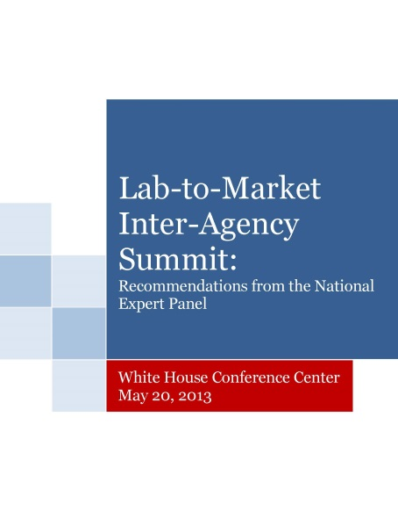
On May 20, 2013, the White House Lab-To-Market Inter-Agency Summit was held in Washington, D.C. The Summit was organized by the White House Office of Science and Technology Policy and the National Institutes of Health’s Heart, Lung, and Blood Institute. The purpose of the meeting was extraordinary: asking national experts outside of the federal agency system to recommend ways to increase the return-on-investment for the $140 billion annual taxpayer expenditure on federally-funded research and development.
The Final Report
The format for the meeting also was unusual. Research agencies nominated 20 national experts experienced in various phases of technology commercialization to participate in the Summit. The Administration placed no preconditions or limitations on the expert Panel and asked it to focus on “transformative” ideas. We were privileged to be asked to serve as the Summit’s co-chairs.
The Administration requested that the Panel address several overarching questions:
- How can agencies better align themselves to more effectively promote the commercial development of their research;
- How can effective metrics for various stages of these efforts be developed; and
- How can we better leverage multi-agency resources to enhance the public’s return-on-investment through the commercialization of more federally-funded technologies?
We began the day by reviewing five federal programs designed to help bridge the gap between where federal R&D funding ends and private sector willingness to fund commercial development begins. The Panel took its charge of coming up with transformative ideas to heart, and the discussion quickly turned to ways in which we could fundamentally improve-- not just “tweak”-- the current federal R&D system.

We identified several barriers that prevent or inhibit more effective commercialization including:

- Lack of a cross-agency process for identifying and leveraging common research objectives, thus preventing the formation of multi-agency research and commercialization initiatives;
- Lack of a consistent prioritization of technology transfer and commercialization as high agency priorities despite numerous laws and Executive Orders;
- The need to bring many federally-funded technologies to a later stage of development in order to attract private sector partners;
- Lack of knowledge and experience in the federal R&D system with identifying private sector market needs; and
- Industry frustration with unnecessary complexity and difficulties completing licensing and other deals with federal agencies, particularly affecting small business dealings with agencies and federal labs.

All of this was accomplished by the noon break; the afternoon was spent on proposing practical solutions to eliminate these barriers. It became clear that one overriding problem was the lack of an effective body that could see the bigger picture, and be able to help coordinate R&D and commercialization efforts with the aim of creating greater efficiencies and results. Currently, there is no one body which systematically looks for overlaps in agency research, effectively assists in leveraging multi-agency programs, or identifies and helps apply best practices in commercialization across agencies.

Further, clear metrics are needed to serve as guideposts for progress along the way. Finally, it was apparent that innovative commercialization programs needed greater protection and support to insure that undue bureaucratic barriers are not hindering or blocking private sector deals with government agencies.

Thus, the first unanimous recommendation of the Panel was the creation of an Office of Innovation and Federal Technology Partnerships within the White House Office of Management and Budget (OMB). This home was selected for two reasons: OMB has the authority to oversee the development of budgets for all agencies; and OMB insures that basic policies are being effectively implemented across all departments. Thus, it has sufficient clout to do the job. Because of OMB’s broad existing authorities the new Office could be quickly and effectively established there without having to wait for new legislation to be enacted. This is not to say that the Office could not be placed elsewhere, including at a Secretarial level, but OMB is the most expedient and practical location in the near-term.

We also recommended that the Office establish an External Advisory Board composed of private and non-profit sector representatives to provide on-going review and input from an experienced practitioner’s perspective.

Not stopping there, the Panel went on to look at recommendations for strengthening capital investments and creating the entrepreneurial resources needed for greater commercial development of federally-funded technologies.

These ideas included:
- Testing new vehicles including partnerships with philanthropic foundations investing in needed technologies, creating a national early-stage “fund of funds,” and expanding already successful programs for accelerating the development of early-stage technologies;
- Creating tax incentives for companies supporting scale-up and proof-of- concept work for the commercial development of publicly-funded technologies;
- Expanding entrepreneur-in-residence programs across federal agencies and promoting the placement of federal scientists in industrial research facilities;
- Expanding training to federal agency and lab employees to become more familiar with technology commercialization and industrial practices.
- Creating “technology translators” experienced in the commercialization process to work with public sector researchers through their technology transfer or business development offices;
- Allowing more SBIR/STTR funding to be used by awardees for intellectual property protection, marketing, and business development needs; and
- Creating new contract/grant vehicles in SBIR/STTR facilitating interdisciplinary R&D across programs and federal agencies.

Not bad for one day’s work!
Authors:

On August 6, 2013 the recommendations of the Panel were officially submitted to the White House. While we put much more time and energy into this project than expected, the results and the experience of so many talented people working together for the benefit of our country made it truly worthwhile. Let’s hope that this hard work is actually put to use and that these recommendations will be seriously considered.
Joe Allen

We can’t afford to sit on our hands as other countries pass us by. While the U.S. created the historic model for linking cutting-edge public sector research with private sector development, we will have no one to blame but ourselves if we now fail to adopt best practices for commercializing our publically funded R&D. There’s still time to reassert our traditional R&D leadership—but it’s fleeting. The Panel report shows a promising way forward.
Diane Palmintera

The full report can be accessed here:
http://innovationassoc.com/files/WH.L2MSummit.Recommendations.FINAL.Aug.09.2013.-2.pdf
For further information you can contact Joe Allen at jallen@allen-assoc.com and Diane Palmintera at dpalmintera@innovationassoc.com.

